Entangled Encounters, Assignment 1: Complete Package

Artifact: Vision AI, an "AI as Mirror" web app → https://istem-ai.github.io/met/
Submitted by: Eagle Chan
Partner exchange: Dave Leblanc

Contents
Entangled Encounters, Assignment 1: Complete Package 1
- Artifact Statement 2
- Process Documentation 3
2a. Prompt chain 3
2b. Interventions and judgment 3
2c. What I asked for vs. what the AI added unprompted 4
2d. Abandoned directions, surprises and refusals 4
2e. Documented outputs (screenshots) 5
- Entangled System Profile 6
3a. Scan of all ten dimensions 6
3b. ECOLOGICAL (required) 7
3c. DATA (selected) 8
3d. RELATIONAL (selected) 9
References 12
- Making Statement (187 words) 13
- AI Acknowledgment 13

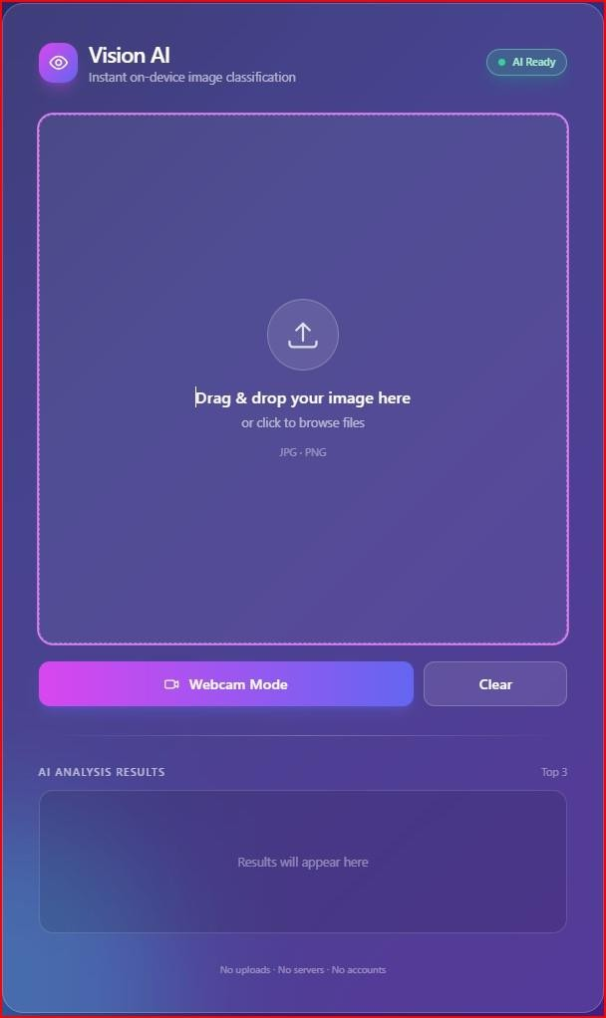
Artifact Statement

Artifact: Vision AI, an "AI as Mirror" web app → https://istem-ai.github.io/met/
Vision AI is a single-file web app. It runs
MobileNetV2 in the browser through TensorFlow.js and classifies an uploaded image or a live webcam feed. It returns the top three guesses as confidence bars. The webcam preview is mirrored, but the classifier receives the raw, un-mirrored frame.
The metaphor: a mirror normally shows you
yourself. This one shows how a machine sorts the world into about 1,000 categories it was given in advance. The mirror is only as wide as its vocabulary.

Process Documentation

2a. Prompt chain

Step | Prompt (summary) | What I delegated | What I decided
 | Role, stack, features, constraints | Nothing yet | Single file, no backend, no accounts, everything local
1 | Glassmorphism UI, no JS | Visual design | Layout skeleton, with the results area reserved
2 | Drag-and-drop, preview, "X" clear | Event handling | PNG/JPEG only, subtle clear button
3 | Load MobileNet, "Waking up the AI…" → "AI Ready" | Loader and badge | Wording and tone
4 | Top-3 bars | Rendering | Top 3, plus the percentage label format
5 | Webcam, 300 ms loop | Camera and loop logic | The 300 ms interval
 | "Separate the code in half… continue" | Output splitting | The workaround, plus the final integration

2b. Interventions and judgment
  - Decomposition as authorship. I split a multi-day build into five sequenced jobs, "like assigning jobs to helpers." The model never saw the whole design. I held the architecture and acted as integrator.
  - Constraints as ethics. "No backend, no accounts, no database, everything stays in the browser" was my decision. It set the privacy profile of the whole artifact.
  - Token-limit workaround. I asked for the final script in two halves and merged them into a coherent file with four script blocks (input, loader, classifier, webcam).

2c. What I asked for vs. what the AI added unprompted
This comparison is FOUND by reading the prompts against the code. It is evidence for the Creative and Relational dimensions.

Requested in my prompts | Added by Claude without being asked
Glass card, header, square drop-zone, webcam button, results box | Animated background blobs, the "Vision AI" name and eye logo, subtitle "Instant on-device image classification"
"Waking up the AI…" and a green "AI Ready" badge | A "Warming up the neural network" warm-up pass, a retry button, an "AI Unavailable" error state
Top-3 bars with "Label (85%)" | A "Best match" tag, staggered bar animations, hover text showing the raw ImageNet label
Webcam every 300 ms | Mirror-flipped preview, a scan line, a LIVE badge, camera shutdown when the tab is hidden, friendly camera-error messages
PNG/JPEG upload and clear | A 20 MB cap, stale-result guard (runId), keyboard and ARIA accessibility
"Everything stays private in the browser" | The footer "No uploads · No servers · No accounts"

2d. Abandoned directions, surprises and refusals
  - Abandoned direction: a server-side model. I considered running a larger model on a server. I dropped it because it would have meant hosting, accounts or logging, and collecting people's images. It would also have moved the compute (and the environmental cost) somewhere I couldn't see or control. It conflicted with the "mirror" idea, since a mirror shouldn't keep a copy of your face.
  - Surprise 1: the layout is more beautiful and professional than I would have made.
  - Surprise 2: a plant that is not in the model's vocabulary still received three confident-looking labels (see Figure 3).
  - Surprise 3: the "85%" on the loading screen is not a real download percentage (see Algorithmic note below).
  - Refusals: I refused accounts, databases, analytics and uploading images to a server. I also refused to ship a backend "for accuracy."

2e. Documented outputs (screenshots)

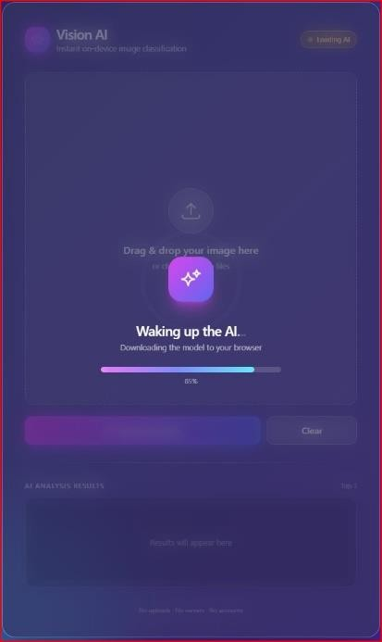 | 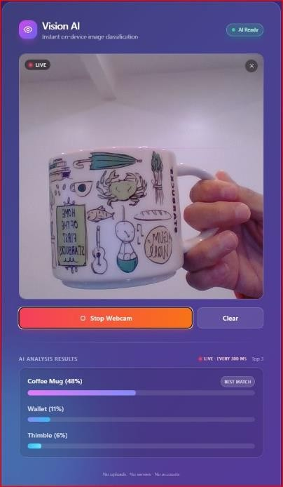 | 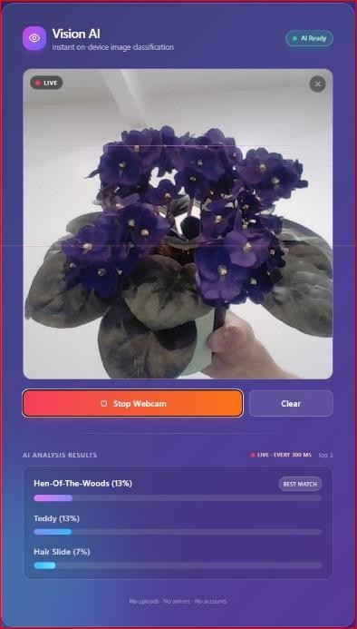
Fig. 1: Loading screen, "Waking up the AI…", 85% | Fig. 2: Webcam on my Starbucks souvenir mug | Fig. 3: Webcam on my African violet
In the code, the progress bar eases toward about 92% on a timer and jumps to 100% when loading finishes. It is not tied to bytes downloaded (FOUND in code). The "Waking up the AI" wording also treats a model download as an act of waking something alive. | The label is correct, and the model was fairly confident. It cannot see what the mug is: a Seattle souvenir ("Home of the First Starbucks," "Gum  Wall") that carries meaning for me. Wallet and Thimble are surprising neighbours. I read the printed text in the preview mirrored, but the model sees the un-mirrored frame (FOUND in code). | "African violet" is not among the 1,000 ImageNet classes. The model reached for the  nearest visual matches, a ruffled mushroom, a fuzzy toy and a hair clip. The top two are tied at 13%, yet  the UI still shows one "Best match." The flat distribution is a signal of uncertainty that the interface hides.

Entangled System Profile

System investigated:
- MobileNetV2, trained on ImageNet and run in the browser via TensorFlow.js.
- Claude Sonnet 5.5, the generative model that wrote the code.

3a. Scan of all ten dimensions

Dimension | One-line scan
Data | The classifier's world is ImageNet's roughly 1,000 labels, built from web-scraped photos and crowd-worker verification.
Algorithmic | The model always returns three guesses, even when none fits. Claude added "Best match" and a progress bar that doesn't measure real progress.
Ecological | Training, hosting, delivery and inference are all material, but the interface shows none of it.
Futures | The app normalizes the camera as an input device and machine sorting as a friendly service.
Creative | Claude contributed the visual style and code. I contributed the metaphor, constraints, sequencing and integration.
Relational | I became director and integrator instead of coder. Many people behind the system became invisible.
Political | Model weights, CDNs and the LLM are controlled by large organizations. Their rules and availability shaped what I could build.
Disciplinary | Prompt-chaining challenges what counts as programming expertise in education and design.
Epistemic | A percentage bar looks like authority. The model's categories are treated as ground truth.
Knowledge construction | Testing real objects in real time taught me the model's limits faster than reading about them.
Deep dive: Ecological (required), Data, Relational. I chose these because the mirror metaphor raises three questions: what was the mirror made from (Data), what does it cost to run (Ecological), and who is in the room with it (Relational).

3b. ECOLOGICAL (required)

Where did you look?
  - The index.html code.
  - The interface itself (screenshots, Figs. 1–3).
  - Course reading: Kudina & van de Poel (2024), on AI as part of larger systems.
  - Public research on AI energy and water use (Strubell et al., 2019; Luccioni et al., 2024; Li et al., 2023).

Found / Observed / Conjectured
  - FOUND (code): After the model loads, classification runs on the user's device. Images are not sent to a server. In webcam mode the loop runs about three analyses per second (300 ms), and the camera is shut off when the tab is hidden.
  - FOUND (code): Tailwind, TensorFlow.js and MobileNet are all loaded from external CDNs on page load, so the app depends on network infrastructure and data-centre hosting.
  - OBSERVED (Fig. 1): The loading screen says "Downloading the model to your browser." That is the only hint that anything material is happening. The interface displays no energy, water or hardware information. The only number about the process is "LIVE · every 300 ms" (Figs. 2–3), which tells you speed, not cost.
  - OBSERVED (Figs. 2–3): Results arrive instantly and smoothly. The speed and animation make the process feel weightless.
  - CONJECTURED: MobileNet was trained on GPU or TPU clusters in data centres. That means electricity, cooling water, chip manufacturing and mined minerals. I cannot see any numbers.
  - CONJECTURED: Building this app with Claude required several rounds of large-model inference, including the long final code generation and the "continue" step. Each used data-centre compute that I never saw.
  - CONJECTURED: My local-only design shifts part of the compute from a server to the user's laptop or phone, so the cost is relocated, not removed.

What remains unclear?
  - The training footprint of MobileNetV2 and of Claude Sonnet 5.5, and where that compute ran.

  - The energy and water cost of a single prompt or of one hour of webcam mode.
  - The footprint of CDN delivery and of my own device's manufacture.
Ethical question or tension My privacy-first design (no servers) can still hide ecological cost behind the sense that "it's just my browser." Who bears the cost of an instant, free-feeling experience: the people near data centres, mining sites and fabrication plants, who never see the interface? Is a small, playful artifact worth costs I cannot measure?
Why this matters for the artifact A mirror suggests immediacy and lightness. The "reflection" here is physically produced, through a device, a network and distant data centres. I cannot honestly call the app weightless, and I disclose that in this profile.

3c. DATA (selected)

Where did you look?
  - TensorFlow.js MobileNet model documentation.
  - ImageNet documentation (Deng et al., 2009).
  - Excavating AI (Crawford & Paglen, 2019) and Yang et al. (2020).
  - Sharma et al. (2025), as a parallel on reuse of creative data without consent.
  - My own tests (Figs. 2–3).

Found / Observed / Conjectured
  - FOUND: The model is trained on the ILSVRC subset of ImageNet, about 1.2 million images in 1,000 classes. Labels come from the WordNet hierarchy, and the images were gathered from web searches and verified by crowd workers (Deng et al., 2009).
  - FOUND: The 1,000 classes include many dog breeds and many specific objects, but no general "person" class. Verify against the class list.
  - FOUND: Crawford & Paglen (2019) showed that the wider ImageNet "person" categories contained offensive and stereotyping labels. Some were removed afterward (Yang et al., 2020).
  - OBSERVED (Fig. 2): My Starbucks mug got "Coffee Mug (48%)." This is a correct and fairly confident answer for a generic, common object that is well represented in the training data. The model cannot read or register the meaning of the printed words and drawings.

  - OBSERVED (Fig. 3): My African violet produced "Hen-Of-The-Woods," "Teddy" and "Hair Slide" at low confidence (13%, 13%, 7%). The model has no label for it, so it matched shape and texture to what it does have. The result is a poetic mismatch, but it is still the system's version of "what this is."
  - CONJECTURED: The photos were taken, uploaded and indexed by people who didn't know they were becoming training data. I cannot say which images shaped any single prediction.
  - CONJECTURED: The dataset favours what English-language web search surfaced around 2009, so it likely over-represents consumer, Western, object-centred imagery.

What remains unclear?
  - Exactly which images were used, who owns them, and under what conditions they were collected.
  - Whether the specific weights loaded by the app were modified or fine-tuned.
  - What Claude's training data included, or how it shaped the interface style it produced.
Ethical question or tension Whose photographs became the "ground truth" for what the mirror can recognize, under what conditions, and who benefits? The photographers and the workers who labelled images received no credit or compensation that I know of. I then built a free app that gives their work back to users as if it were neutral fact.
Why this matters for the artifact The mirror can say "Coffee Mug" quickly but cannot say "souvenir from Seattle," and it has no word for an African violet. Those gaps show where the data stops, which makes them the most honest part of the artwork.

3d. RELATIONAL (selected)

Where did you look?
  - My prompt history and the generated code.
  - My experience of building the app, compared with building a similar app earlier (which took days).
  - Course readings: Kudina & van de Poel (2024), on how people, rules and institutions shape technology; Koch et al. (2026), on friction and reflection; Sharma et al. (2025), on hidden contributors.

  - Screenshots (Figs. 1–3).

Found / Observed / Conjectured
  - FOUND (prompts, code): Claude added many things I didn't request: the app name and logo, the "Best match" tag, the animated background, and the privacy footer. See Section 2c.
  - OBSERVED: My role changed from writing code to directing, reviewing and integrating. Work that took days took much less time.
  - OBSERVED (surprise): The layout is more beautiful and professional than I would have made. My feeling was mixed. I was pleased with the result, and I also noticed that I hadn't done that part of the making. I had chosen to accept it.
  - OBSERVED (Fig. 2): I held up an object that matters to me, and the system treated it as one common product. The relation between me and my object stayed mine, because the machine's reflection did not touch its meaning.
  - OBSERVED (Fig. 3): "Teddy" for my plant was an odd, almost affectionate answer. I noticed myself reading personality into a statistical near-match.
  - CONJECTURED: The purple-indigo gradient, glass card and soft glow follow design conventions that are common in the web content and code examples Claude was trained on. The "professional" look may come from many designers' work I cannot trace.
  - CONJECTURED: Because I wrote the constraint "everything stays in the browser," my future users relate to this app as private. That depends on their trusting the page, since they cannot easily verify it.
  - CONJECTURED: The webcam mode weakens the usual distance between the user and the machine. It watches you, and your face may become a test object.

Relationships strengthened, weakened, replaced, hidden

Relationship | Effect
Me ↔ my work | Strengthened at the level of concept and decisions; weakened at the level of craft
Me ↔ Claude | Newly possible: a collaborator-like helper, though not a person and not accountable
Me ↔ other makers (designers, programmers) | Replaced / hidden: the aesthetic labour of many designers sits behind the style

Relationship | Effect
Me ↔ photographers and crowd workers behind ImageNet | Hidden: they are invisible in the interface
Me ↔ open-source maintainers (TensorFlow.js, Tailwind, CDNs) | Hidden but depended on: the app can't run without them
Me ↔ audience / users | Newly possible: private, local interaction;  risky: webcam trust
Me ↔ partner (Dave Leblanc) | Possible: the exchange lets us compare the encounters, so human judgment can check the machine's

What remains unclear?
  - How much of the visual design is Claude's "choice" and how much follows widespread conventions.
  - Who the designers and developers behind that style are, and whether they consented to their work being learned from.
  - How the end users will feel about a camera-based app, which I haven't tested.
Ethical question or tension Which relationships did the system make possible, and which did it hide? It gave me speed and polish, but I lost direct contact with the labour, the makers and the data subjects whose work made it possible. I can claim authorship of the concept and decisions. I cannot easily credit or compensate the people whose contributions I benefited from.
Why this matters for the artifact The metaphor of AI as a mirror ignores the people standing behind the glass. In Koch et al.'s (2026) terms, the smooth process removed friction that might have let me reflect on what I was accepting. Naming the relationships restores part of that reflection, and I treat it as part of the artwork.

References
Crawford, K., & Paglen, T. (2019). Excavating AI: The politics of images in machine learning training sets. https://excavating.ai
Deng, J., Dong, W., Socher, R., Li, L.-J., Li, K., & Fei-Fei, L. (2009). ImageNet: A large-scale hierarchical image database. 2009 IEEE Conference on Computer Vision and Pattern Recognition, 248–255.
Koch, J., Liao, X., & Casiez, G. (2026). AI as friction for reflection support in ideation. Proceedings of the First Reflection in Creative Experience (RiCE) Workshop, ACM Creativity & Cognition 2026, London, UK.
Kudina, O., & van de Poel, I. (2024). A sociotechnical system perspective on AI. Minds and Machines, 34(3), Article 21. https://doi.org/10.1007/s11023-024-09680-2
Li, P., Yang, J., Islam, M. A., & Ren, S. (2023). Making AI less "thirsty": Uncovering and addressing the secret water footprint of AI models. arXiv:2304.03271.
Luccioni, A. S., Jernite, Y., & Strubell, E. (2024). Power hungry processing: Watts driving the cost of AI deployment? Proceedings of the 2024 ACM Conference on Fairness, Accountability, and Transparency (FAccT '24).
Sandler, M., Howard, A., Zhu, M., Zhmoginov, A., & Chen, L.-C. (2018). MobileNetV2: Inverted residuals and linear bottlenecks. Proceedings of the IEEE Conference on Computer Vision and Pattern Recognition, 4510–4520.
Sharma, T., Zhou, Y., & Berisha, V. (2025). PRAC3 (Privacy, Reputation, Accountability, Consent, Credit, Compensation): Long tailed risks of voice actors in AI data-economy. arXiv:2507.16247.
Strubell, E., Ganesh, A., & McCallum, A. (2019). Energy and policy considerations for deep learning in NLP. Proceedings of the 57th Annual Meeting of the ACL, 3645–3650.
Yang, K., Qinami, K., Fei-Fei, L., Deng, J., & Russakovsky, O. (2020). Towards fairer datasets: Filtering and balancing the distribution of the people subtree in the ImageNet hierarchy. Proceedings of FAT* '20, 547–558.
TensorFlow.js MobileNet model documentation (accessed 2026).
Anthropic. (n.d.). Claude documentation, usage policy and terms of service (accessed 2026).

Making Statement (187 words)
I began with a metaphor: AI as mirror. The encounter taught me that a mirror is never neutral. Held up to my Seattle souvenir mug, Vision AI said "Coffee Mug (48%)"—correct, yet blind to the Gum Wall and the first Starbucks printed on it. Held up to my African violet, it offered "Hen-Of-The-Woods (13%)" and "Teddy (13%)": the plan t doesn't exist in its 1,000 words, so it reached for the nearest ones. The mirror reflected ImageNet, not me.
My judgment lived in the framing: the metaphor, the five-step decomposition, the no-server, no-account constraint, and the refusal of a server-side model. Claude Sonnet
5.5 did the typing, and its interface was more polished than I would have made. That surprised me, and unsettled me: I also accepted a "Best match" label on a tie, and a footer that overstates privacy. Fluency invited trust.
I cannot see the energy, water, or labour behind each generation, nor the photographers and crowd workers behind the labels. Making felt like directing, yet the relationships I depend on stayed hidden. Next time I would design pauses, uncertainty, and acknowledgments into the work.

AI Acknowledgment
The code for Vision AI was generated with Claude Sonnet 5.5 through the sequential prompts documented above. I designed the concept (AI as mirror), architecture,
constraints and prompt sequence, tested the output with my own objects, and integrated the two halves of the final file. The in-browser classifier is MobileNetV2 (TensorFlow.js), trained on ImageNet. All observations come from my own screenshots. Findings about code come from reading the delivered index.html.

